 Pegasys
[Generate Transaction Summary Report]

- Transaction Summary Report—Generates a listing of all transactions that have been entered in Pegasys, organized by Approving Official, date, and reconciliation status. The Report Level, Fiscal Year, Fiscal Month, Fund Code, Organizational Code and BBFY are the parameters entered to generate this report.
Note: The Date Range is a required parameter. The Approving Official and the Credit Card Alias must be entered in the exact
format as shown below. The date range must be entered in the MM/DD/YYYY format. Status can be
selected from a drop-down menu.
Figure 1
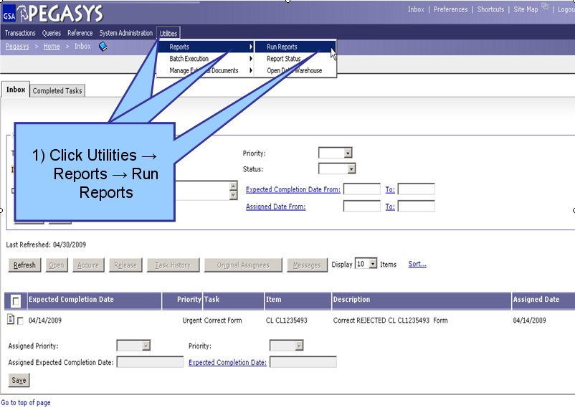
Figure 1

- From the Pegasys homepage, click on Utilities on the Menu Bar
- Click on Reports.
- Click on Run Reports.

**View Reports page is displayed for all available reports**
Figure 2
Figure 2

- Click the “+” box next to the Purchasing folder to expand this folder. (Step 1)
- Click the “+” box next to the Reports folder to expand this folder. (Step 2)
- Click on Transaction Summary once to highlight this report. (Step 3)
- Click the Select Report button after the report is highlighted. (Step 4)
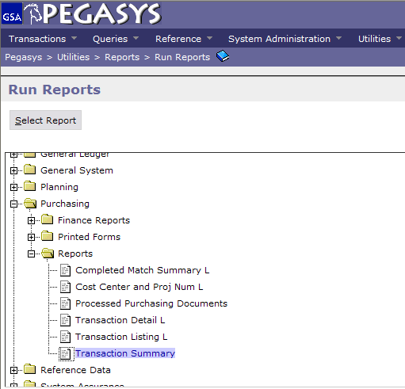
4) Click Select
Reports
1) Click Purchasing

2) Click Reports
3) Click Transaction
Summary
(OVER)

Figure 3
Figure 3
- Enter Fiscal Year, Fiscal Month, Fund Code, Organization Code and BBFY (Step 1)
- Click Run when finished. (Step 2)

**Report Level will default
**If the report has been generated, a message display will appear under the breadcrumbs track that says, “The report has been successfully submitted.”**
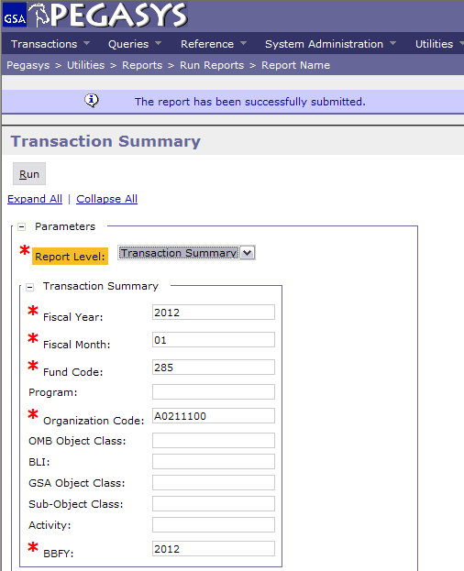
1) Enter Fiscal Year
Enter Fiscal Month
Enter Fund Code
Enter BBFY
2) Click Submit

Pegasys
[View Transaction Summary Report]

Figure 1
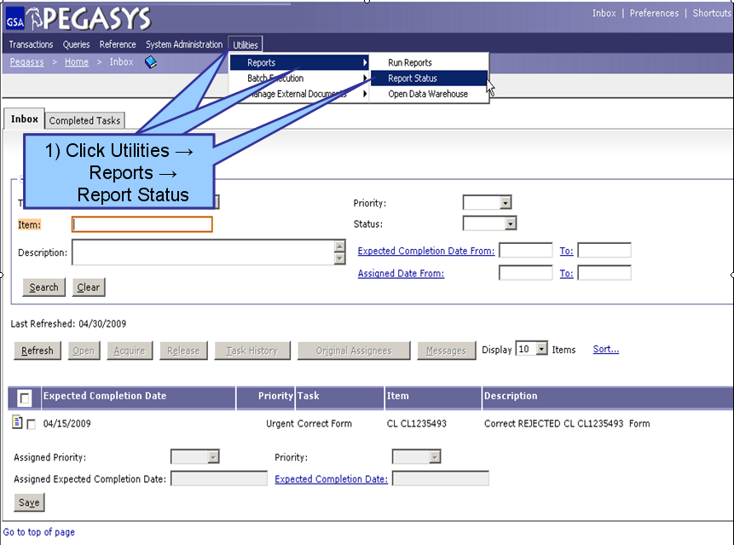
Figure 1

- From the Pegasys homepage, click on Utilities on the Menu Bar
- Click on Reports.
- Click on Report Status.

**Report Status Maintenance is displayed for all processing and/or completed reports**

Figure 2
Figure 2

- To find a report, the user can search by Report Subsystem. Enter all known information. (Step 1)
- Click Search. (Step 2)
- When the results are returned, select a report from the populated field. (Step 3)
- Click Details after the report is selected. (Step 4)
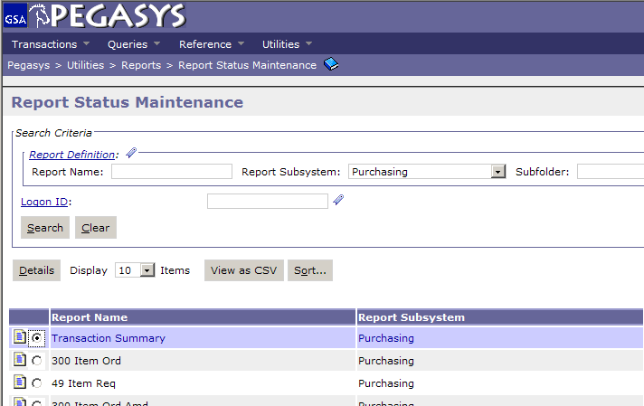
1) Search by:
Subsystem
2) Click Search
3) Select the Report
4) Click Details

Figure 3
(OVER)
2) Click Output
Figure 3

- On the Report Executions page, select the report to be viewed. (Step 1)
- Click Output after the report has been selected to view the report as a PDF file. (Step 2)

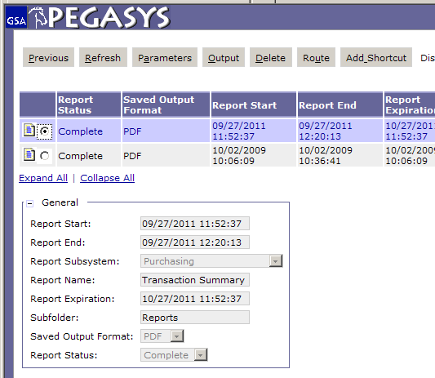
1) Select the Report

